Sea Pollution

It seems that almost everyday there is another story about pollution of one form or another, in the food we eat, the water we drink and the air we breathe. Very often our own actions lead to that pollution and in many cases, almost in all, we can do something about it to make the environment around us a better place, therefore reducing a lot of the pollution. One type of pollution that is common and well-known with us is sea pollution. We use water daily in our homes and industries. The water we use, in our case, is taken from underground (groundwater) and the sea surrounding our island, and after we have used it, and contaminated it, most of it returns to these locations.
The seas and oceans receive human waste; whether it is by deliberate dumping or by natural run-off from the land, although in most cases in fact humans are the causes of this problem. Over 80% of all marine pollution comes from land-based activities and many pollutants are deposited in estuaries and coastal waters. Here the pollutants enter marine food chains, building up their concentrations until they reach toxic levels. This can ruin beaches and bays where people go to swim, and would make the water harmful for them. It also kills marine life, another problem that is increasing.
The used water of a community is called wastewater, or sewage. If it is not treated before being discharged into waterways, serious pollution is the result. Historically, it has taken humanity quite a bit of time to come to grips with this problem. Water pollution also occurs when rain water runoff from urban and industrial areas and from agricultural land and quarrying makes its way back to receiving waters (sea or water-table) and into the ground.
To keep our used water from spoiling our water resources, we have to remove the pollutants before the water gets back into the environment. In our country, the wastewater from homes, businesses and factories is collected by a system of underground pipes (sewers) which carry it to one or more central treatment facilities. Most of these are located near bodies of water into which the treated wastewater is discharged.
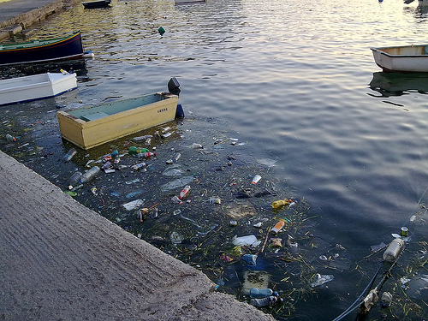
Waste dumped into the water

More different causes of marine life damage include oil pollution, and in fact oceans are polluted by oil on a daily basis from oil spills, routine shipping, run-offs and dumping. Underground storage leakages are another cause of pollution, along with atmospheric deposition, which is the pollution of water created by air pollution, radioactive waste and also global warming, since an increase in water temperature can result in the death of many aquatic organisms and disrupt many marine habitats.
Water demands in the Maltese islands have increased throughout the years as ground water recourses have been exploited beyond their sustainable yield resulting in water shortages, salinity levels in groundwater, and tap water, this has raised the risk for people to be infected with diseases. The increase in pollution, mainly from agro-chemicals, has also caused deterioration in groundwater quality. To try to restrain water extraction from the underground and the poor quality of tap water, the Maltese Government has resorted to large scale desalination by Reverse Osmosis. Unfortunately the nature of the distribution system is such that there is an inequity in the quantity and quality of water supplied. Certain settlements receive little or no water, usually of relatively poor quality, for long periods, while others receive large amounts, usually of the relatively good quality Reverse Osmosis water. These problems and their causes are discussed and solutions are briefly considered.
One of the major effects of sea pollution is the damage to the food chain. When harmful toxins are present in water they are transferred to higher level organisms through the food chain. These toxins are passed on to humans and animals as well. Dangerous pollutants such as lead and cadmium are eaten by tiny animals and these are then consumed by fish and larger sea animals. This food chain is distributed to the higher levels.
Heavy metals like lead, mercury, iron, cadmium, aluminum, and magnesium are present in water sources. If these metals are present in the sediment, these reach the food chain through plants and aquatic animals. This causes heavy metal poisoning in the water.
Polluted water is a hot bed for diseases. Microbial water pollution can spread infectious diseases such as typhoid and cholera from drinking contaminated water. The human heart and kidneys can be badly affected if polluted water is consumed regularly. Many other health problems related to polluted water are poor blood circulation, vomiting, skin lesions and damage to the nervous system. Water pollution is considered to be a major cause of death of the population across the globe.
Oil spilling is hazardous for the marine life. The oil spilled in the ocean could clog up the gills of fishes, thereby preventing respiration. It affects the process of photosynthesis of marine plants, since it blocks the sunlight.

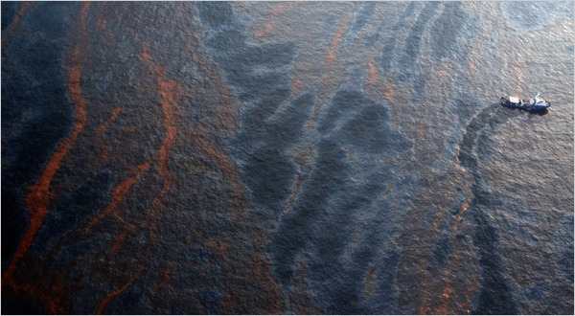
Severe oil spills in the Gulf of Mexico
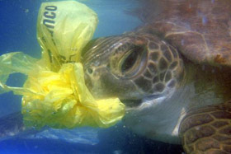
A sea turtle eating plastic

Plastics dumped into ocean can affect the marine life seriously. Plastic items such as bottles and bags could choke and suffocate the sea animals, as they eat them thinking that they are food. Plastics are known to be a major cause for the death of turtles, as they swallow the floating bags, mistaking them for jelly fish.

Even cars pollute the ocean. The exhaust that comes out from the back of the car doesn’t go directly into the sea. It ends falling down as acid rain. Acid rain is pollution mixed with regular rain and when acid rain gets into the ocean it pollutes the water and kills many fish over a period of time.

So, what can one do to prevent sea pollution? Here are some tips that one can follow which can make a difference on the quality of sea water:
- Reuse plastic bags and recycle plastics. Don't throw them away.

- Don't throw trash when you visit the beach

- Make sure your vehicles and boats do not leak oil on the road or in the water. When it rains, this oil will of course be washed away and eventually, via streams, valleys or drains, find its way into the Mediterranean Sea.
- For the same reason, do not flush medications and chemicals down the drain.

- Understanding the importance of marine life for us and making sure that we don't cause harm to them.

Be well aware of your impact on the environment. Everything you do and make use of has some impact on your surroundings. Making intelligent choices and changes in the manner of your everyday living is perhaps the most effective solution for ocean pollution.

