Malta has poorest EU recycling rate... and it's getting worse

Recycling down from 10% in 2012 to 6.7% in 2015 (Source Times of Malta of Monday, November 27, 2017, 11:20 by Claire Caruana)
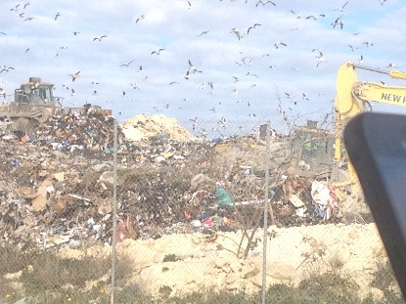

The article of Claire Caruana was published in the Times of Malta recently. According to the same article, the information gathered was obtained from Eurostat from data coming from 2015.
Getting to know that Malta’s recycling went down from 10% in 2012 to 6.7% in 2015 is very alarming because instead of improving the environment we are destroying it.
The people need to learn that it is more expensive to dispose of our rubbish unwisely than recycling it. Waste is mostly disposed of by households. There are various problems arising from lack of waste separation and recycling. Some of these problems are pollution, poverty and environmental damage.
There are different ways to improve our environment. If we can all work together and use our social, economic and environmental capabilities, we can work towards reaching the sustainable development goals.
A short clip named Mottainai Waste Facts & Figures included in the United Nations Environment Programme whereby 17 Sustainable Development Goals have been identified gives some solutions such as: -
Reducing Poverty: with the households’ leftovers we could feed all the homeless and poor people and end world hunger.
Reducing Pollution: employees working in informal waste sector can live healthier and instead work in greener industries as these will grow, contributing to sustainable industrial development and job creation.
According to the UN Environment Programme, environmental benefits that can be achieved:
- house gas emissions can be reduced to 20%;
- integrated waste management reduces CO² which causes the damage of the Ozone layer;
- recycling paper saves trees which contribute by inhaling CO² and exhaling oxygen which is beneficial for our health and the Ozone layer;
- waste gases can be used to power homes and businesses and this will help to reduce from using other oil and gas resources (in Malta in 2009 we managed to light up a Christmas tree for 50 hours from the Maghtab landfill waste gases).
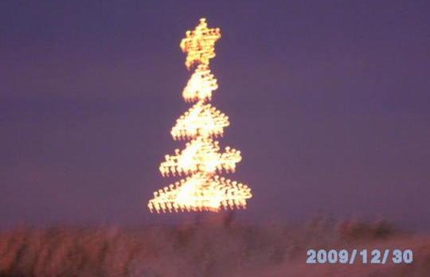
We need to remember that there are many ways to decrease waste, three of which are:

- first reducing waste by putting up a ‘no junk mail’ sign;
- if you can’t reduce it then, reuse it. When you go shopping use a re-usable bag instead of a plastic bag;
- Recycle: a way to do this is by separating waste.

https://www.timesofmalta.com/articles/view/20171127/local/malta-has-poorest-eu-recycling-rate-and-its-getting-worse.664185
https://www.youtube.com/watch?v=mNaOE2zYnFI
http://www.un.org/sustainabledevelopment; http://web.unep.org/ietc/

