Vandalism in Malta
Vandalism is a very big issue in Malta, “People are also vandalizing private properties
because most citizens do not appreciate all like beaches, flats and houses. And they are
the hard work involved into creating a beautiful also vandalizing nature! “said a friend with
place to live in. this issue.
We can not let our country become filled
According my neighbor when tourists come to Malta with ugly vandalism.
they expect to be Share this word if you want vandalism to
Surrounded by nature , but they come to stop ruining our country.

see a lot of vandalism .

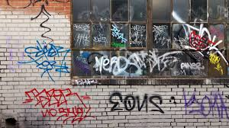
“Even us Maltese citizens , want
Our country to look as beautiful as possible
, but other people do not respect the prestigious
Statues or country side. They just go
and vandalise our country.”said my friend

Last week
A new statue was built in our capital city but
the following day People vandalised it
Made by Thea Sciriha 7.1
In Mosta we had a park near
A CD shop but now it is all broken and Vandalized

.

