GREENS, GREENS.... NOTHING BUT
BUILDINGS!!!
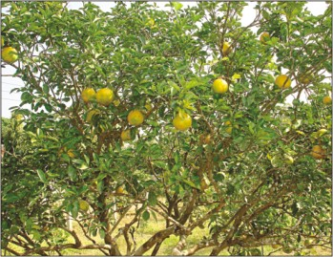 | It is a problem that we do not have as much greenery as we used to because people are using the space to build high residential blocks. Children don’t have anywhere to play, stray animals are feeding on any rubbish left outside populated areas and we are not inhaling fresh air because of the construction.
We reported some neighbours and asked them about what they think about this problem. Sandra Cauchi says, “ It’s a pity because trees are important for a healthy enviorment as they release good oxygen.” Jesmond Greg says, “ The more we build in the same area, the population will be which brings about traffic problems and fewer recreational parks.” | 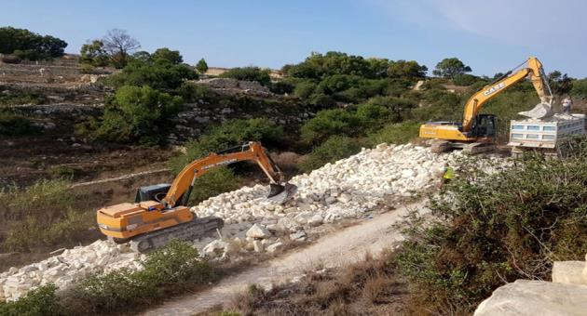
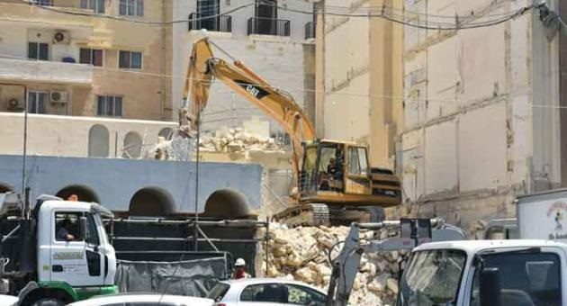 | The people that we reported think that we should start a campaign to stop this once and for all, so then people and animals can enjoy some fresh air rather than polluted air caused by the increase in trucks and cars on the roads. They also said that they are hoping that this problem will be solved in the very near future.  By Sara Debono + Tamara Pavia

