Students turn spotlight on Mental Health
-8th October 2018-
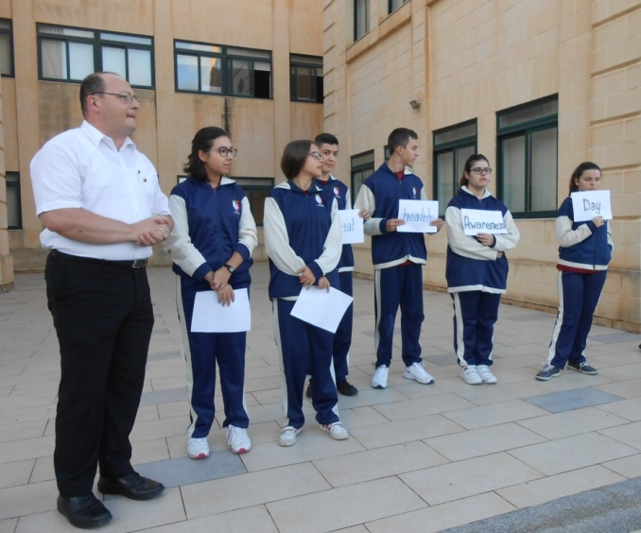
World Mental Health Awareness Day is celebrated every year on the 10th October and St. Margaret College Verdala School Queen’s Young Leaders Group assembled with their group founder teacher, Martin Azzopardi to raise awareness about mental health during the school morning assembly.
Mental health affects the way a person manages his daily burdens or problems, his relationship with others and also his decision taking. According to a systematic review of data and statistics from community studies in European Union(WHO/EU) countries, one out of every four persons in Europe experiences a form of psychiatric problem in life and the situation in Malta is not that far from the EU statistics.
Mental illness takes various forms and levels of severity. Schizophrenia and Bipolar mental illness are both considered as severe types of mental illnesses which affect 1% of the population. On the other hand depression is more common to find and it affects around 15% of the population.
St Margaret Queen’s Young Leaders Group was founded in 2014 and every year they get inspired by the speeches of HM the Queen Elizabeth II to write and publish articles promoting moral values. So on the day dedicated to Mental Health Care, St Margaret Queen’s Young Leaders Group invited school students to reflect upon the causes of mental illness.
Surely the prime cause of mental illness is the daily stress which needs to be handled with care. Then there is the use of drugs and alcohol which surely affects mental health. On the other hand, some medical conditions (like the thyroid deficiency) can also affect mental health.
In this regard, some students were invited to say what causes mental tiredness in students’ lives and the following are some of the students’ thoughts:
Student Jody Pacesaid “I think that labelling students as ‘failures’ or ‘low achievers’ can lead them to feel mentally stressed” and student Mariah Sciberras thinks that “smoking and drugs are surely affecting young students’ minds throughout their daily life”. “Social family problems are causing lots of mental stress in youths”according to student Yasmine Grima and “too much pressure from parents in achieving high scores at school can lead to mental stress and tiredness” according to student GraziaMagro.
Student Nicolai MagriCaruana says that “having too many lessons and subjects at one go can make you feel stressed” and “lack of family love and support is the cause of stress and mental illness in children and youths” says student Xavier Sant.
Student Nicolai Pace adds that “all sorts of bullying causes stress in students which surely affects their daily life” and “excessive use of technology without limits can affect our mind” says student Owen Vassallo.
According to WHO/EU statistics, the issue of mental illness is increasing and so we need more awareness, education and action in this regard. The EU insists on having more national strategies and implementations to safeguard mental health especially amongst students and youths.

