Dive Against Debris
According to National Geographic, 40% of the plastic that we use is single use and so ends up in our waterways. No one knows exactly how much unrecycled plastic waste ends up in our ocean. Since this percentage of plastic is getting higher and higher, Aquaventure, a dive centre in Mellieha decided to do something about it!
Lee Martin, the manager of Aquaventure stated that they do about 20 dives per year to collect sea debris. The debris consists of pieces of rubber, toiletries, nappies and sanitary items. There are millions of pieces of debris in our ocean and Aquaventure is trying its best to decrease it; pictured left is a sample of what they collected on their last dive.
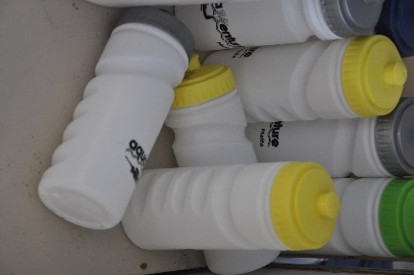
Aquaventure also helps against single use plastic, instead of buying water in plastic bottles they sell reusable bottles which are bought once and then kept to be refilled with water. This decreases the usage of plastic not only on their beach but everywhere as the reusable bottle can be taken home and reused.
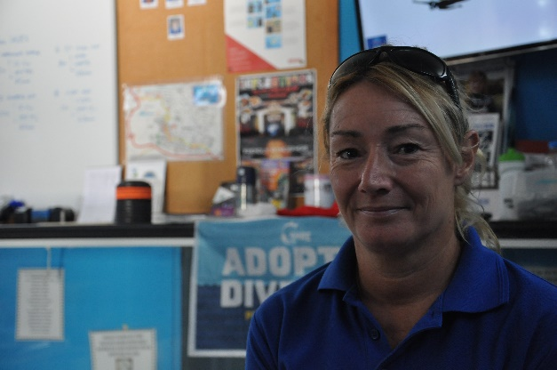
Lee Martin also commented “single use plastic is not only bad for our environment but also for us”, as tiny microplastics get in the sand and are washed out to sea and when the fish eat these tiny pieces of plastic they end up in humans! In fact there have been finds of microplastics in the deceased people!
Lee concluded that “We should all care about this problem as it is not going to get smaller unless we all do something, it does not take much to use a reusable items instead of single use plastic, I myself care a lot about our ocean, fish and beaches.”
A group of YRE students have gone to Mosta square to ask some people if they know about all of the damage and how much plastic there is in the oceans. Out of the 14 people who were interviewed, half of them did not know about all of this, most of them commented “This problem is getting out of hand, I had no idea that it was so large, I will try and use more reusables now”.
Care about our ocean
Stop plastic!
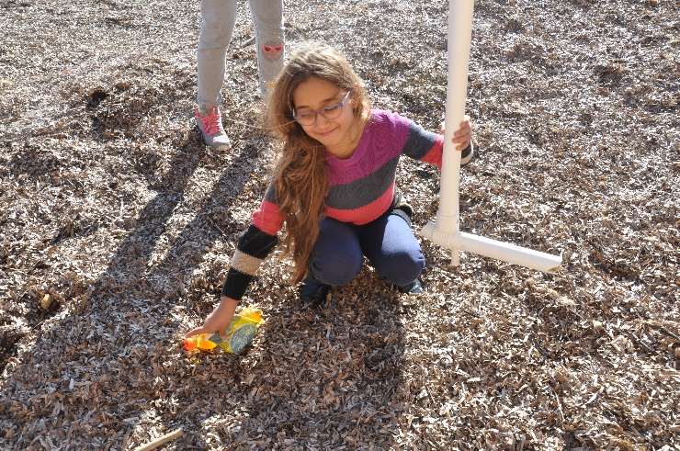

Kids caring

