‘Change your ways, reduce your waste’
One of the sustainable living goals is ‘Partnership’ which can be achieved by giving empowerment to citizens. Initiatives like EWWR (European Waste Week Reduction) bring together thousands to come with practical solutions and activities to reduce waste and increase recycling. This is an ideal opportunity to make difference for the environment.
The theme for this year was entitled ‘Change your ways, reduce your waste!’, which was centred around the idea that we can relate to the waste problem on Earth and we can do something about it. That is why it is highly advisable to promote our actions to have appositive impact on others and therefore encourage other to change their behaviour.
Our school participated in EWWR. To mark this event, school Green Leaders in collaboration with the Eko Skola team, tried to create a sound awareness regards effective waste management techniques. This was done through various communication means and measures to reuse plastic to embellish our school environment which is already surrounded by nice green areas. Plastic bottles were re-used as bird feeders and pots. Sometimes with a little more thought and creativity we can save money and most importantly save our environment from the exhausting plastic waste.
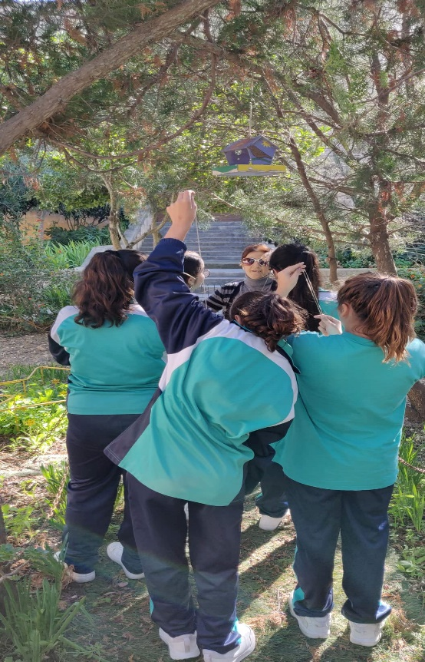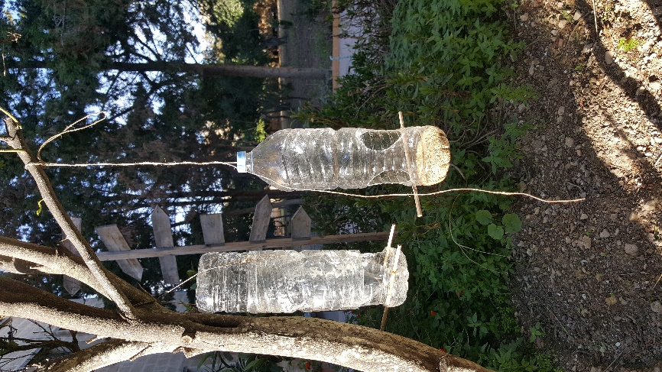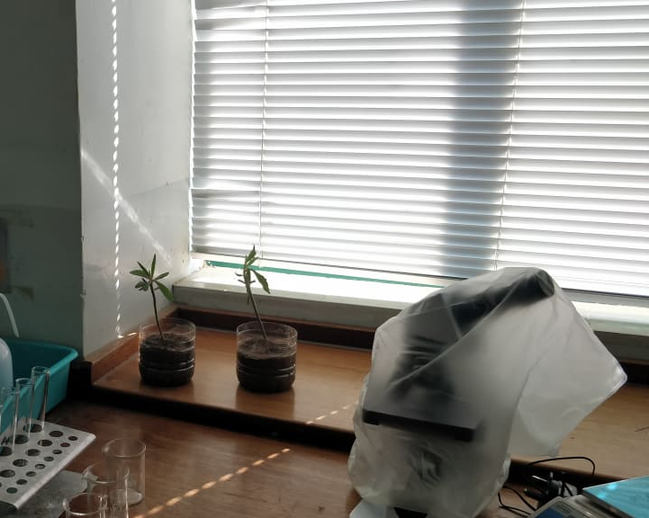

Reusing is the way forward to reduce waste, so our team also encouraged all students to bring along to school a lunch-box and a re-usable plastic bottle daily. This is helping to reduce plastic waste at source.
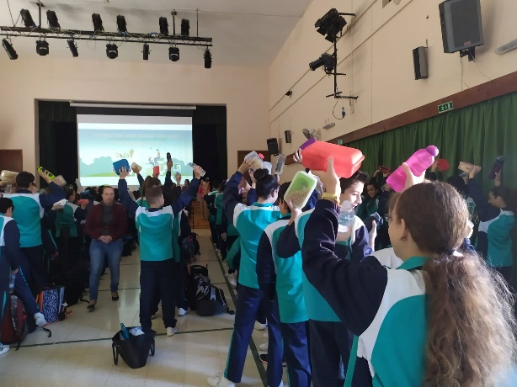

Everyone can contribute to waste reduction. This week is used to sow in us ideas to reduce the amount of waste thrown away. However, we hope this seed than grows into sustainable citizens that make wise choices thus help the environment.
Vanni Caruana
St. Thomas More College
Secondary School Zejtun

