

Malta:

Developing into a Multicultural Society

Luke Graham Cassar
ID 372104L
St Clare College Secondary
March 2020

Introduction:

Maltese people since ancient times were always renowned to be friendly and hospitable towards foreigners. This has even been recorded in the Bible in the account of St Paul’s shipwreck – see end note 1.
Evidently, Malta is no stranger to visitors and immigrants and has always had a number of foreigners in its midst, largely due to its position, directly in the middle of the Mediterranean. As a people, the Maltese population have always had to adapt to integrate with different races and cultures – be it to get along with other citizens that settled in Malta or even to adapt to its foreign governors. But due to developments in the last two decades, the influx of foreigners is much greater now than it has ever been.
In this project, I will firstly discuss the circumstances causing the increase of multiculturalism in Maltese society owing to the influx of foreigners. I will then analyse a study by a local newspaper that found that some Maltese young people are resisting this shift in society towards a more inclusive and diverse society. I have interviewed a number of students at the school I attend, St Clare College Secondary, to ascertain or negate the findings of the newspaper’s study.

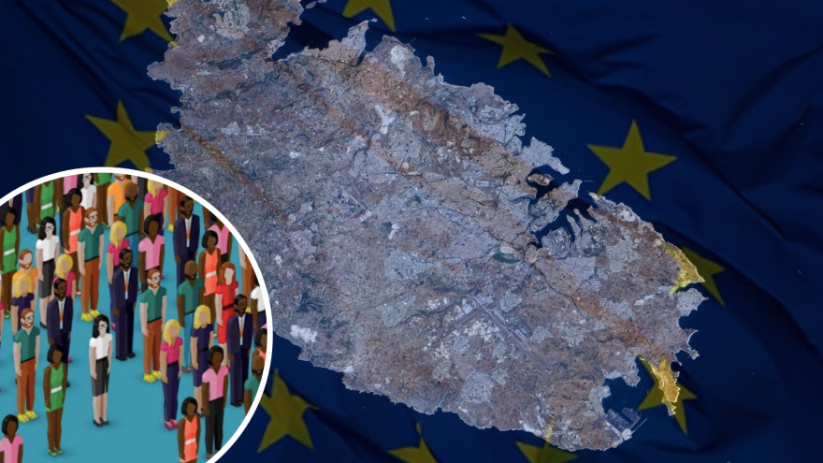

Definition and Research:

The word ‘multicultural’ refers to ‘several cultural or ethnic groups within a society’.
The National Statistics Office’s (NSO) most recent publication - Key Figures for Malta - Visuals and Words - 2019 Edition – states the following:
The total population as at the end of 2018 was 493,559, of which 251,836 were males and 241,723 females. Total population grew by 4 per cent compared to 2017 and by 20 per cent compared to 2008. A contributory factor was the net migration of foreigners. In the 10 year span 2008-2018 the number of foreign nationals in the population grew five times over.
The Times of Malta reports that “one in every seven people in Malta is foreign”.
Eurostat states that: “Relative to the size of the resident population, Malta recorded the highest rates of immigration in 2017 [in Europe] (46 immigrants per 1000 inhabitants)”.
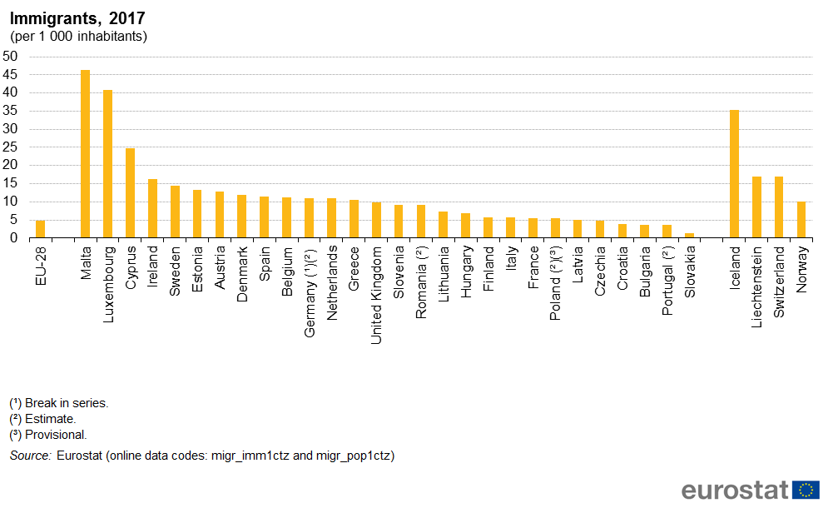

Currently, many people are entering Malta with varied intents. The reasons for the migration of foreigners to Malta range from seeking refuge to finding work:
- Asylum seekers that are eventually granted refugee status;
- Irregular immigrants, seeking a better life for themselves, often heading to mainland Europe and ending up on our shores;
- People that take the Investment-based citizenship scheme (passport) and have become Maltese citizens;
- Retired individuals who choose to retire in Malta;
- Workers from the EU and other countries seeking better work opportunities.

The largest quantity of immigrants falls under the last category – those coming to Malta seeking work, due to Malta’s growing economy.
Malta is seen as an attractive place to immigrate to because many feel that it is a safe and secure country with low crime rates, as well as stable and pleasant weather. These factors are important and can be a deciding variable for people who wish to immigrate to a different country.
According to a report by ‘Lovin’ Malta’ as reported in March 2019, 80,331 EU nationals were at that time living in Malta. Apart from EU countries, Libya, Serbia and The Philippines are the three countries with the most residents living in Malta.
The conflicts in Syria, Ethiopia, Sudan and other countries, as well as the political instability in Libya, have also brought a number of people into Malta in the form of refugees. Refugees risk all, even their own lives by trying to travel across deserts, seas and entire regions to get to safer countries. These refugees are different from other immigrants because their reason for leaving their own country is usually because of fear of war/conflict or persecution. Along with refugees, many people especially due to the low employment opportunities in sub-Saharan countries, also flee in this way to Europe. These are usually called irregular immigrants.
In order to attract foreign investors, Malta has many company taxation benefits, which attracts companies to set up in this country. This opens up many job opportunities, which in turn attracts more people from other countries to Malta.
Irrespective of which of these channels people go through to move to Malta, many of these immigrants come with their families, and this is reflected in the fact that our schools today are a mix of many different nationalities, religions and cultures. Malta has become a melting pot of cultures – where it is normal to see people of all skin colours and creeds living and working together.
New residents enrich the cultural fabric of Maltese society by introducing new foods, music, traditions, beliefs and interests.
These foreigners bring with them, not only their customs and beliefs but also their attitudes and viewpoints. Their ideas and mindsets may therefore be different to that of the local Maltese people. A section of Maltese society may tend to get offended when they feel that the Maltese way of life is challenged or disrespected. Most Maltese people do not try to impose their culture onto these foreigners, but do, to a certain degree, expect that the Maltese way of life is respected and undisturbed.

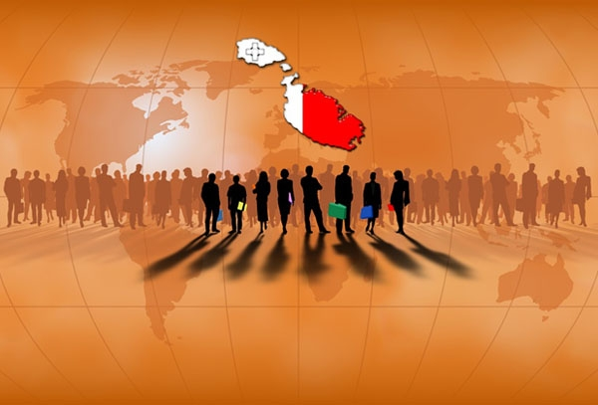

Effects of multiculturalism in schools
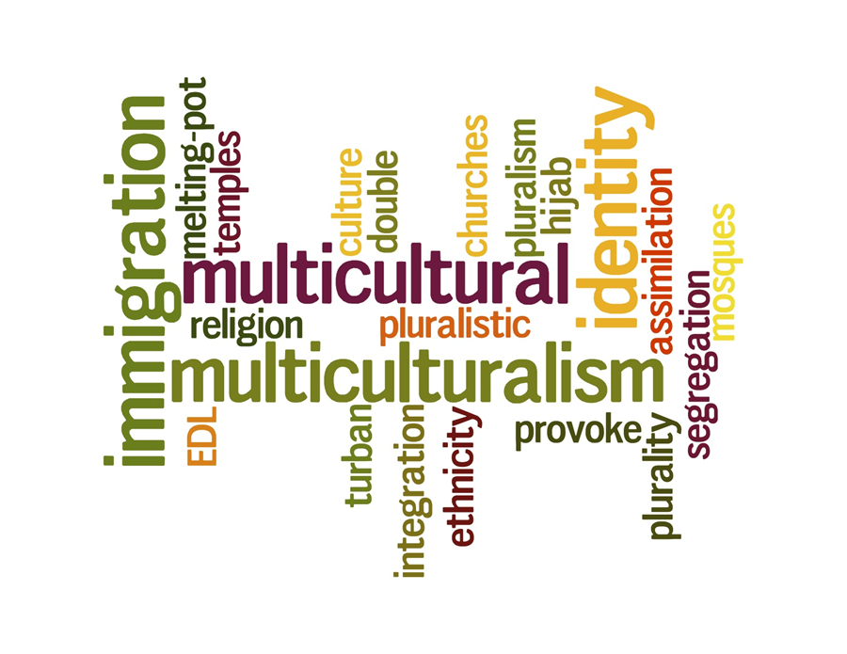
Multiculturalism and diversity in schools has many positive aspects. It is believed that students work better when they are in a diverse environment and this enables the students to focus and work harder when people of other backgrounds work alongside them. Immigrants can be a source of diverse knowledge and experience and this potentially could have the effect of increased innovation and creativity in a school context.
Moreover, multicultural education helps eliminate stereotyping and prejudice. It contributes towards there being a reduction in fear caused by ignorance of the unfamiliar. When students are co-educated in a diverse environment, they are able to form friendships and therefore feel less of a detachment towards minority groups, and this leads to minimized racism and discrimination.
However, the differences between cultures still remains. Not all foreign students integrate seamlessly with the locals at our schools.
For the second part of my project, I have explored the effect of multiculturalism on Malta. Schools are becoming an interesting mix of cultures and nationalities. However, there is not always perfect harmony between all. The effect I will be focusing on is the resistance and hesitance to multiculturalism displayed by children and young individuals in schools.
According to local newspaper MaltaToday,
“Interaction between Maltese children and foreign children in schools remains limited, with roughly a quarter of Maltese students hesitant and resistant to multiculturalism”.
The study also looked at the behaviour of native students and found that while half of Maltese students had foreign friends, social interactions with foreign children were limited, with most Maltese students spending most of their time with other Maltese people. This can result in conflicts, ranging from physical fights to bullying.
In this project, I intend to find out whether this is true for students in the school I attend.

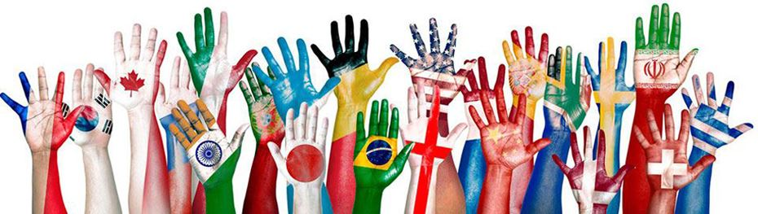

Interviews

To analyse and compare with the MaltaToday study, I have interviewed ten students at my school – St Clare College Secondary School – five foreigners and five native Maltese students. In our school, the presence of foreigners is heavily felt, and the school management organizes activities were students from abroad can showcase their culture in order for them to be able to fully integrate in the school community, and for the local students to get to know them better.
The questions I asked them are below, and the answers are attached in section ‘Appendix’.
Interview – Maltese Students
1: Do you have foreign friends?
2: Where have you met these foreigners?
3: Do you hang out with foreign friends outside of school?
4: Have you ever asked them over to your house?
5: Why do you enjoy spending time with your foreign friends?
6: Do you think their culture and customs affect you as a person? For instance, if they don’t celebrate Christian holidays, how does that affect your relationship with them?
7: When you are around foreign people, but speaking to another Maltese person, do you speak English to help include them in the conversation?
8: Do you think that the fact that there are many foreign students in our school changes the environment somehow? If so, how?
9: Do foreigners that hang out with other foreign students accept locals such as yourself as part of their group?
10: Do you think foreign students are treated well and respected by other students?

Interview – Foreign Students
1: Are any of your friends Maltese?
2: Where have you met these Maltese people?
3: Do you hang out with Maltese friends outside of school?
4: Have any of your Maltese friends ever asked you over to their homes?
5: Does the fact that Maltese culture and customs are different from your own, affect your relationship with Maltese friends?
6: Do Maltese people accept you into their friend group? Or do you find yourself surrounded by foreigners?
7: When Maltese students are around you, do they try to speak English to help include you in their conversation?
8: Do you think foreign students would accept locals as part of their friend group?
9: Do you think that the fact that there are many foreign students in our school changes the environment somehow?
10: Do you think foreign students are treated well and respected by Maltese students?
The answers were then compared and contrasted and can be found in section ‘Results’. The data collected is being used to test an existing hypothesis – the MaltaToday study, mentioned in the previous section.



results

All of the interviewees said that they have friends of different nationalities.

Maltese students:

Some Maltese students disclosed that their closest friends were actually foreigners. The majority said that they met these foreigners at school, a few said they met them at after-school activities such as basketball practice. They all claimed that they spend time with their foreign friends outside of school hours and that they have occasionally asked them over to their own homes.

The Maltese students said that they enjoy spending time with their foreign friends because they like learning about new cultures. One respondent said that they far greater enjoy the company of foreign students, because they are more fun-loving and because Maltese kids are close minded.

When asked how the different cultures and customs affect the relationship between them, they stated that the differences don’t affect them at all and they are not bothered by the fact that they don’t celebrate Christian holidays like themselves, for instance. They hang out together because they like each other for their personalities, and they don’t mind the religious or linguistic difference.

Many said that they usually speak English so that their foreign friends feel included and more comfortable around them.

When asked whether they feel that the school environment has changed because of the presence of so many foreigners, all the Maltese students replied in the affirmative. However, their reasons were contrasting. Two said that this makes the school community more interesting, diverse and welcoming. The others said that they feel that the Maltese are foreigners in their own land, and that foreigners are used to different rules and don’t conform to school rules here. One said that having so many foreigners in the school, constricts the school into removing things that are local and intrinsically Maltese, so that foreigners feel welcome.

When asked whether Maltese kids are accepted in friend-groups of foreign students, the Maltese students interviewed seemed to agree that not all foreigners would be willing to socialize with Maltese students.

When asked whether they feel that foreign students are treated well and respected by local students, not all agreed that this is the case. One said that foreign students would be respected by the Maltese if they in turn respect the locals. Three others said that not all Maltese students respect foreigners. Another said that some Maltese people stereotype foreigners at times, and would generalize to an entire nation when one person of that nationality breaks the rules or does something wrong.

Foreign students:

The foreign students that were interviewed said that they have a few Maltese friends, but most said the majority of their friends were also foreign. The majority said that they met these locals at school, a few said they met them at after-school activities. They all claimed that they spend time with their Maltese friends outside of school hours, even if not a lot of time, and that they have occasionally been asked over to their homes.

When asked how the different cultures and customs affect the relationship between themselves and their Maltese friends, the responses were diverse. One admitted to having an identity crisis – they feel disconnected from their own culture and yet certainly do not feel like they are Maltese. One said that they were given the opportunity to blend in with the Maltese as the environment at school enabled them to adapt. Another interviewee said that they think the Maltese are ignorant and close-minded and so they are unable to form relationships with Maltese students. The other two respondents said that their relationship with Maltese students isn’t negatively affected, to the contrary, they feel that these differences make the relationship more interesting.

When asked whether Maltese students accept them into their friend-groups, they all agreed that they generally are accepted but that they are still mostly surrounded with other foreign friends. One commented that they are sometimes kicked-out of the group because the Maltese believe they are better than them.

The interviewees said that some Maltese kids speak Maltese in their presence on purpose to keep them out of the conversation, or even to annoy them. It seems that all respondents agreed that the Maltese don’t make much of an effort to speak in English to include the foreigners. However, one interviewee saw the positive side to this by saying that this has helped them to learn Maltese quickly.

When asked whether they think foreign students would accept locals as part of their friend-groups, many replied in the affirmative. One reason given for this was that the foreigners are less racist than the Maltese. One person said that they don’t think Maltese students would be accepted since foreigners have strong bonds between themselves and would not be ready to accept the locals with their different beliefs.

When asked whether they feel that the fact that there are many foreign students in our school changes the school environment, they all replied in the affirmative. They mentioned that the teachers must speak English and that certain topics are avoided in order for the foreigners not to be offended. They said that having lots of foreigners causes diverse ideas and opinions and that this was not necessarily a positive thing. One respondent said that they felt constantly afraid that they will say the wrong thing and someone gets offended.

Asked whether they felt well treated and respected by Maltese students, sadly all of the respondents replied that they do not feel respected by all. Some said that many Maltese students treat them well, but not everyone. One said that the feeling might be mutual however, as the two groups find it hard to accept and understand each other.



Conclusion
In conclusion, the MaltaToday study has been proven somewhat true. According to my research, some Maltese students do accept and welcome the friendship and culture of foreigners living amongst us. Others, find it difficult and prefer sticking to people of their same nationality. However, I don’t think it’s a case of intentionally doing so – in my opinion, it is probably just easier to continue to speak Maltese and hang out with the same friends. It is more of a lack of effort, rather than consciously pushing back or not accepting foreigners because of their culture. There are the odd few in our school who spew inappropriate comments toward foreign members of our school community, resulting in the foreign children forming their own friend groups, but fortunately, these are in the minority.
Personally, I have friends from all corners of the world and love interacting with people from other lands as I feel this enriches my knowledge and gives me the opportunity to see the world from different viewpoints.
I suggest that during PSCD lessons, this topic is discussed in all grade levels, in order for the local students to be made aware of the situation. I believe, that once Maltese students are alerted to the fact that foreign students sometimes do not feel welcomed or included in their friend groups, they will be more attentive to this and respond by being more friendly and hospitable toward them. The cross-cultural activities organized by the school should perhaps be held more often, as this will increase the awareness and knowledge about people from other countries and their customs. This will help strengthen the school community, and in turn this will benefit Maltese society as a whole.
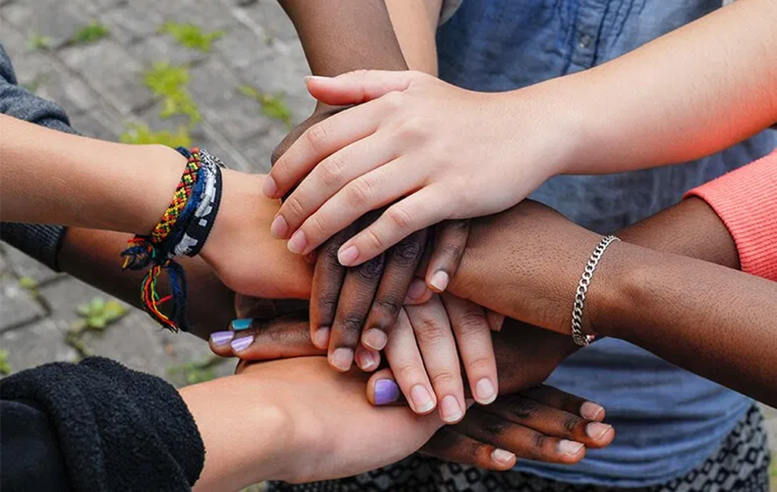

end notes
- Acts 28:1-2:

“Once safely on shore, we found out that the island was called Malta. ² The islanders showed us unusual kindness. They built a fire and welcomed us all because it was raining and cold.”

Bibliography/references
Sources:
- MaltaToday (article: Study finds one in four Maltese pupils are resistant to multiculturalism) (Online) (Accessed on 30/11/2019)
- Wikipedia (definition of multiculturalism) (Online) (Accessed on 30/11/2019)
- Lovin’ Malta (article: Over 100,000 Foreigners Now Living In Malta As Island’s Population Just Keeps Ballooning) (Online) (Accessed on 30/11/2019)
- Times of Malta (article: One in every seven people in Malta is foreign) (Online) (Accessed on 03/12/2019)
- Eurostat (article: Immigration to EU countries: 4.4 million in 2017) (Online) (Accessed on 04/12/2019)
- National Statistics Office (Key Figures for Malta - Visuals and Words - 2019​​​) (Publication)

