Make Your Choice
Reported by Michele Tonna
Do you still buy plastic bottles that are made of single-use plastic? Single-use plastic is plastic that we use once and then throw away. It is also really bad for the environment because if we throw it on the beach, sea animals might think its food. If someone offers you two bottles, one made of single-use plastic and the other is reusable plastic, take the reusable one because if you take the single use you will drink the water and then throw away the bottle.
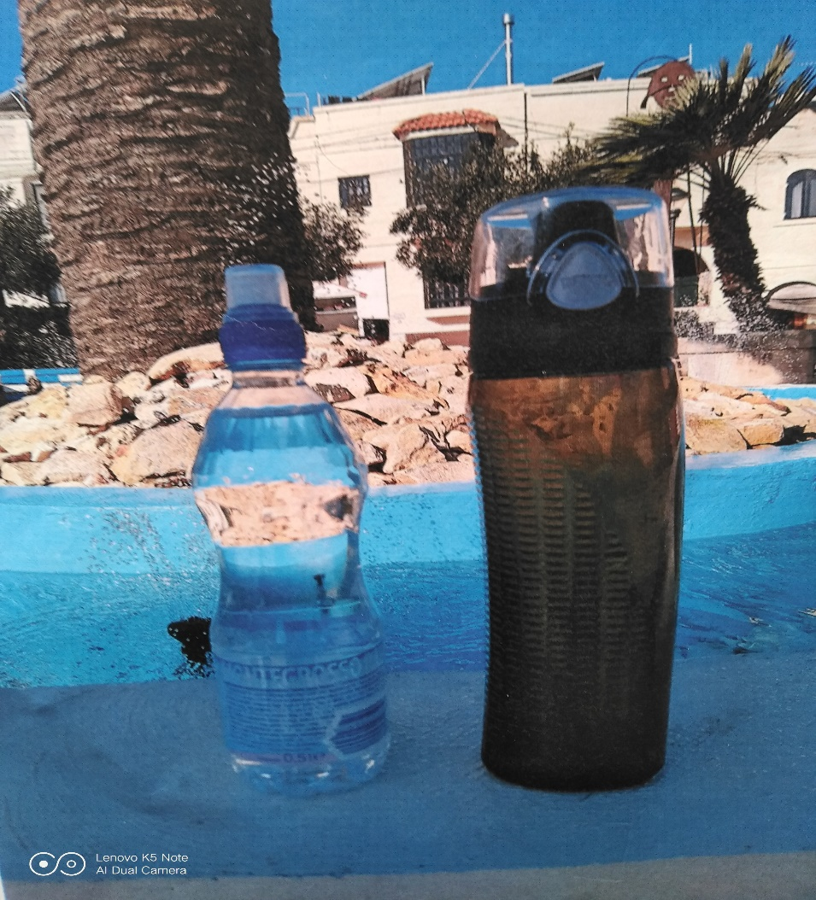
Say No to single-use plastic. Choose a reusable bottle beaker.
Single-use plastic is bad because animals might think it is food, eat it and die. We need to save the world by not buying single use plastic because some animals are getting extinct because of plastic.
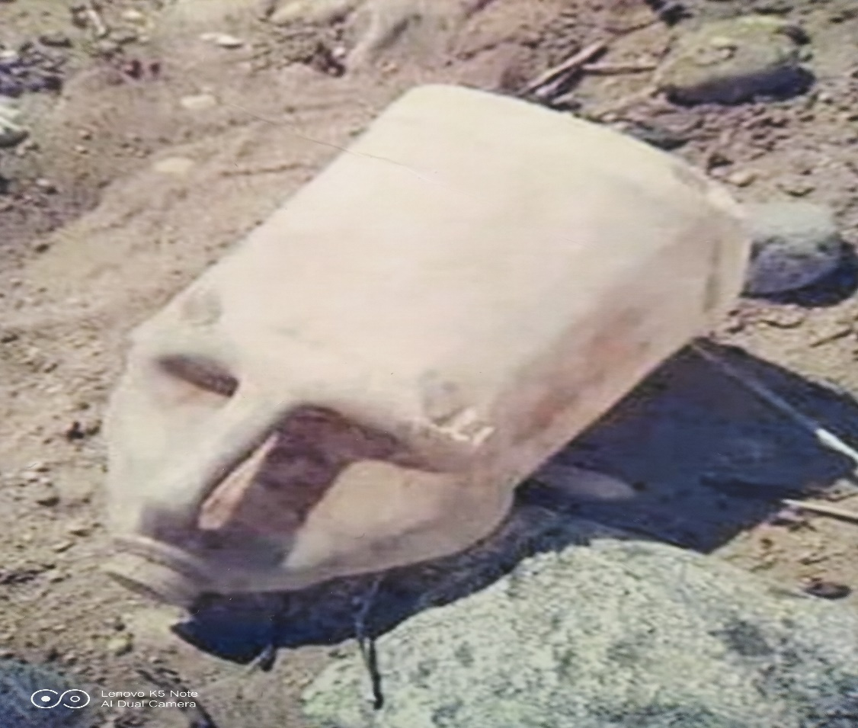
A bottle that looks like an alien’s head.

What can we do about it? At school, the EkoSkola team came up with these ideas: to use reusable bags instead of plastic bags for the St. Martin bags, to use reusable cutlery, plates and cups during the Christmas party and Parent’s Day. On milk days straws are not used but instead children bring their own cups”.

