Plastic - FRIEND or FOE?

Reported by Jayden Chircop

Single-use plastic is in the spotlight, as more and more people opt to reduce them. Places around the world like the U.K., Taiwan, Seattle, San Francisco, Montreal and Vancouver, are joining the plastic free movement. I believe that Malta should take part in this campaign. This means reducing straws, cotton swabs and/or plastic bags. When I asked Ms. Anne Camilleri the Assistant Principal who is also part of the EkoSkola Committee, she told me: “The school is encouraging students to get a re-usable cup for their milk instead of using straws. The school shall guide students to introduce these good habits in their home”.

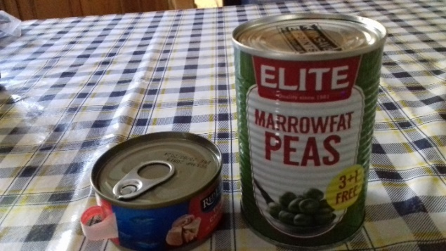
Choose preserved food in cans without wrapping

Research suggests that about 10 million tonnes of plastic currently ends up in the oceans each year. Examples of single-use plastic include: plastic forks and knives, plastic shopping bags, plastic coffee cup lids, plastic water bottles, Styrofoam and plastic takeout containers and of course plastic straws. Glass containers are better than plastic ones because glass can be recycled again and again.

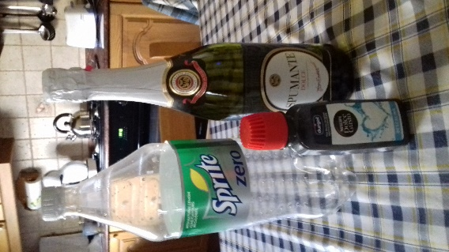
Say NO to PLASTIC, Say YES to GLASS

Single-use plastic is bad for fish, it is killing our beautiful underwater animals. To avoid plastic you should carry your own mug and avoid establishments that don’t offer non-plastic options. Remember: say NO to single-use plastic.

