SUP
A group of enthusiastic teens, with a clear mindset; that to help, even with a small involvement, the environment. The name chosen for our campaign is SUP- Stop Using Plastic Bags. This abbreviation was chosen as ‘sup’ is used between us teens as a slang word for ‘What’s up?’. We wanted our campaign to be relevant for today but also to have a partnership idea; that everyone can contribute to the environment.
This campaign started by designing a distinctive and appropriate logo and setting up of different social media accounts. The latter proved to be a clear demonstration that social media can nowadays support environmental campaigns and connect to people locally and globally. In fact, many of our initiatives were shared by bloggers, and this boosted our enthusiasm. Others started to contribute, like for example, we were given veggie bags to be able to demonstrate alternatives for plastic bags. Colourful posters and stickers were designed appropriately by us to speak for themselves and reach a greater audience. A mascot was used through all the campaign. Being such an eyecatcher, it proved to attract the attention of on-lookers making it easier for us to promote our ideas in the community.
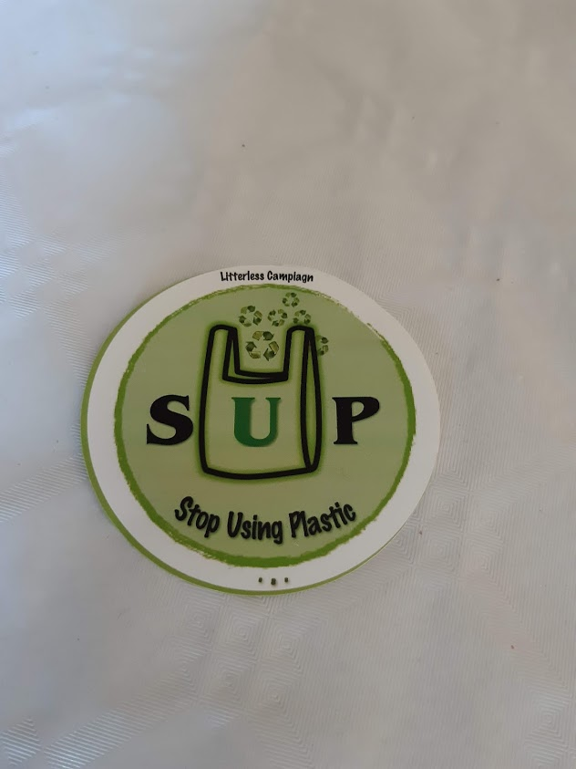
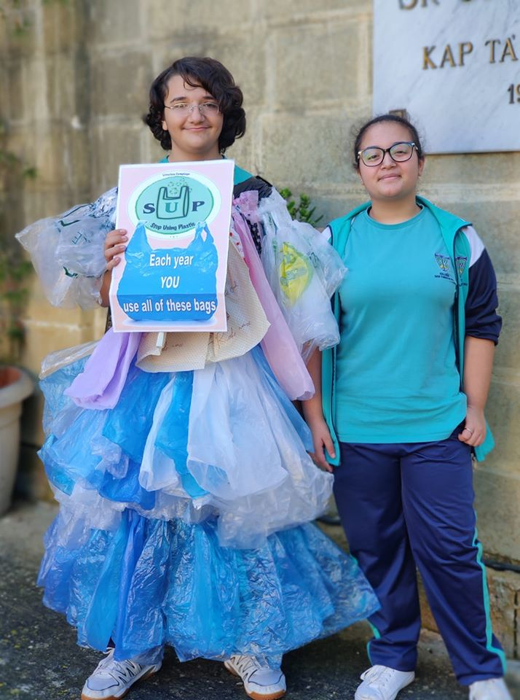
Picture 1: Logo
Picture 2: Mascot
Our campaign was launched during Parents’ Day where a stand was set up with these posters and stickers. Alternatives to plastic bags were given such as the use of bread bags, veggie bags and re-usable bags. In fact, parents reaching our stand were given a re-usable, compact and convenient bag that can be easily carried with them when going shopping. This was all sponsored by Litterless campaign. This contribution evidenced that with a little nudge people would want to help the environment even more. On the other hand, we collected voluntary donations to invest more in our campaign and purchase more bags. A survey was carried out to measure the use of single -use plastic bags.
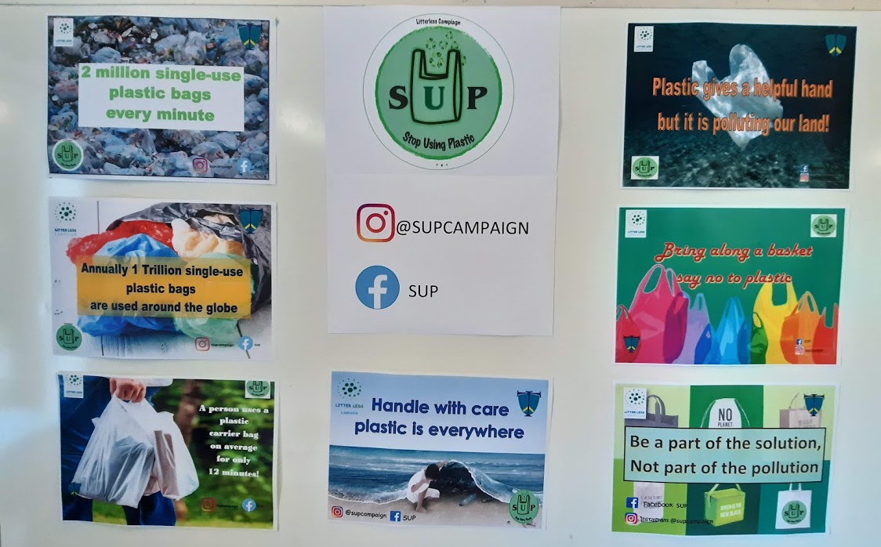
Picture 3: Posters
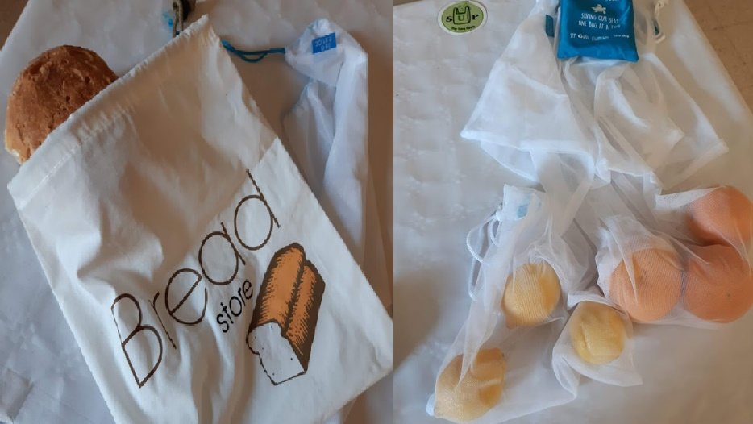
Picture 4: Bread bags and Veggie bags
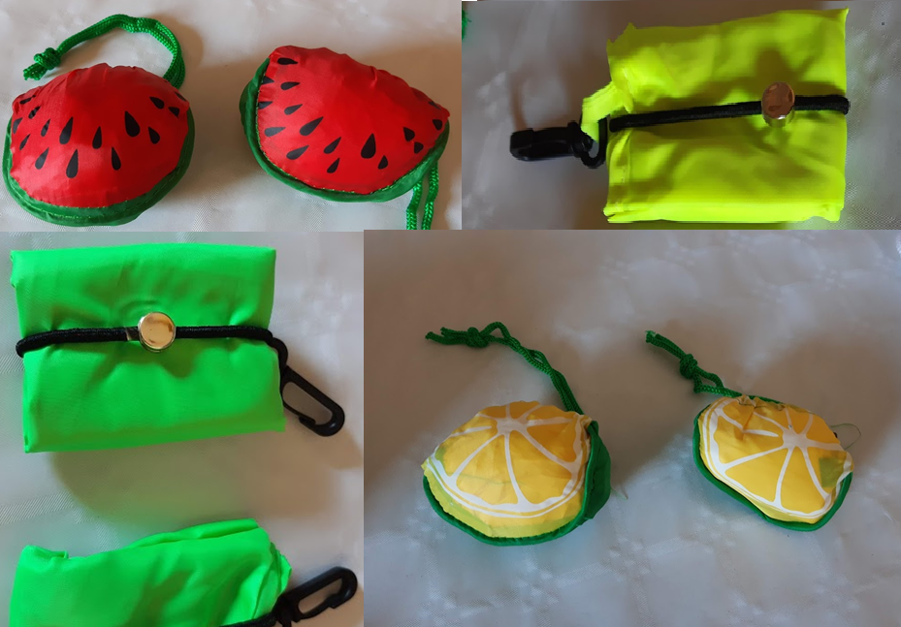
Picture 5: Our re-usable bags
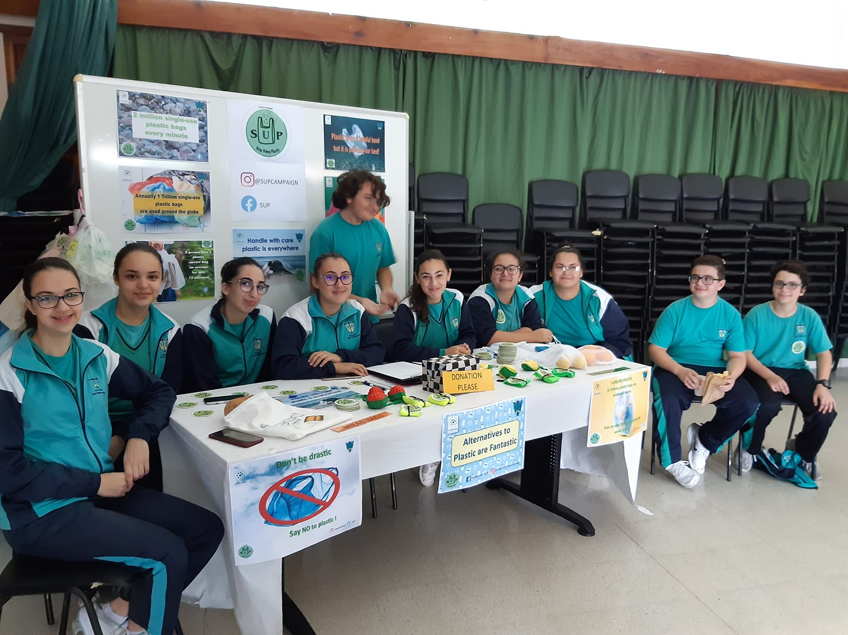
Picture 6: Our stand at Parents' Day
The survey had 68 participants, where 79% of the respondents do most of the shopping in the household. 31 persons confirmed that they do not always take their own shopping bags with them, while another 5 respondents never take it at all. Analysing the survey concluded that meat and poultry are the greatest items bought in single-use plastic bags followed by bread and vegetables (refer to figure 1).

Figure 1: Number of respondents against items bought in single use plastic bags
93% claimed that these bags are either re-used or recycled as garbage bags, storage bags or doggy bags. However, one must highlight the fact that the bags used for meat and poultry are often stained and thus thrown directly in the garbage. 51% and 25% of the respondents claimed that they use about 0 to 5 or 6 to 10 bags per week respectively as shown in figure 2.
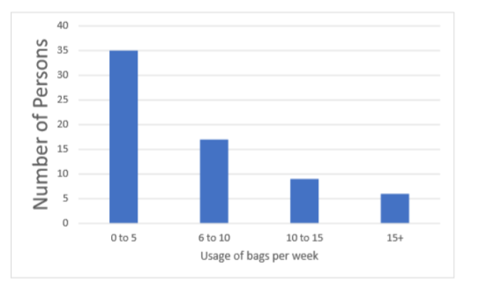
Figure 2: Number of respondent against usage of bags per week
This survey underlined the fact that people need to be made aware of the possibilities available to single-use plastic bags. As a result, we wanted to reach out to the younger generation so that eventually they would voice their ideas to their guardians. Members of the SUP campaign promoted their work during morning assemblies using video clips, presentations and we even distributed SUP stickers to all the students in our school. It was decided to extend our campaign to the public as well, therefore a march in the streets of Zejtun was done protesting the use of plastic bags. We also made our presence at the Zejtun market and stopped consumers who were purchasing products in single-use plastic bags and showed them alternative solutions. The media was also present during this event, and so this helped us to reach even a larger audience. We also provided a re-usable bag to those present and earned enough donations to adopt seven injured turtles. These turtles are currently being taken care of by Nature Trust Malta.
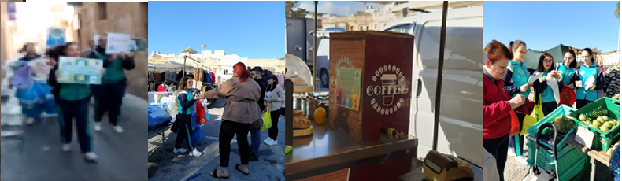
Picture 7: At the market
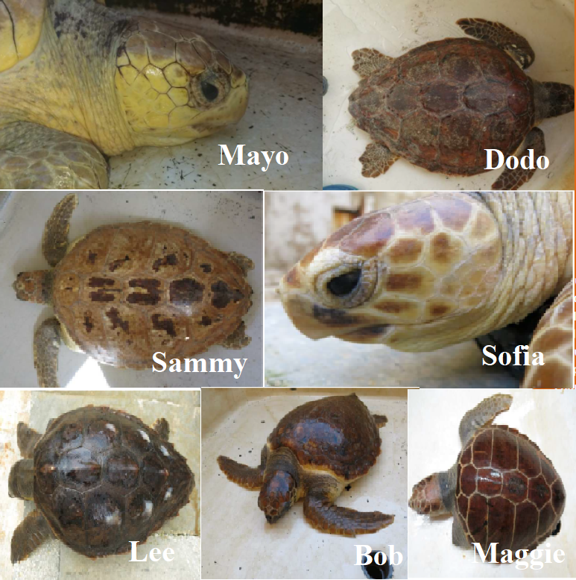
Picture 8: The seven turtles adopted

After three months, the same persons who conducted the initial survey were contacted again and were given another survey to check the effectiveness of our campaign. The majority used the re-usable bags given to them and stated that “they were handy to pop in your bag and carry around”, “practical and environmentally friendly”, “Comfortable size and fits everywhere”. All the respondents stated that after the campaign they reduced the amount of single-use plastic bags in their everyday shopping, with 50% of these also purchased veggie bags and/or bread bags.
We can say that not only the desired goal to educate persons about the damage of single use plastic bags was reached, but we learned other skills such as public speaking, creating surveys, reporting, taking responsibility, budgeting and getting out of our comfort zone which will all be an asset for the coming years. Let’s all give our contribution. Let’s all be active citizens against the use of plastic bags. Let’s all be curious and ask ‘sup’ to any issue around us, so that altogether we maintain our environment clean and safe!

SUP campaign members
Abela Katrina
Attard Daniel
Bonnanno Sera
Borg Kelly
Caruana Vanni
Cassar Leanne
Desira Aiden
Desira Christine
Muscat Nick
Sultana Jodie
Zammit Zoe

Facebook: SUP
Instagram: @SUPCAMPAIGN

