Environmental problems around us

Many people enjoy spending their free time in the various large green areas we have in Malta. These places are very popular with tourists and with Maltese families for picnics and hikes.

Unfortunately, along the pathways of the these places, one may see a lot of plastic bags, orange peels, paper, packets of wet wipes, plastic bottles, packets of sweets, cigarette butts and tissues. This happens although there are several rubbish bins placed in the areas. One may also see pieces of broken glass which are dangerous for others, especially for young children.

All this make me feel sad, angry and ashamed as this shows how careless certain people are. Littering can lead to soil, water and air pollution. It also leaves a bad impact on the environment because hazardous chemicals can leach out of the litter and pollute the soil and water nearby. Litter may be a threat to certain species, such as reptiles, and other small animals as they may become trapped in plastic bags and suffocate. We should be aware that there is life on land and that we need to keep these places clean and beautiful as we are ruining nature and the environment around us. It is a shame that we litter the environment that we need to live in.

I suggest that when people go for a picnic, they should always take an empty plastic bag so they will put their litter in it and dispose of it properly later.
More TV programmes, articles on local newspapers and posters in public places need to be done to show people the effects of littering and how to reduce it.
Everyday, we can all do something to prevent litter and make our community safer and cleaner.

cigarette butt paper
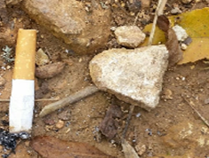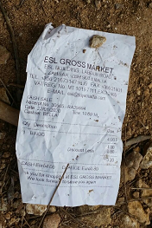

plastic bottle orange peels
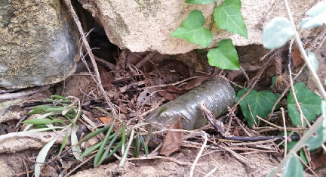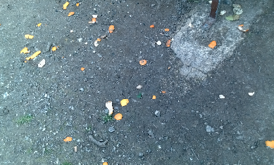

tissues broken glass
