Waste Caused By This Dreadful Pandemic

Covid-19 hit the whole world like a bomb. No one anticipated that such a microscopic virus could tarvel all over the world. In a few months nearly every country started going into lockdowns , schools were forced to close down and most people started working from home or were at the edge of losing their job due to the poor economy. At 12:30pm every Maltese citizen would be distraughtfully waiting to hear what Professor Charmaine Gauci had to announce. Cases kept increasing and so did the restrictions until Malta went into a partial lockdown and people only went out to work or to buy groceries or medicine. The streets were silent from the noise and air pollution.
By summer COVID-19 cases decreased drastically and everyone thought it was over and met up with friends and family until cases started rising again. In the meantime schools opened and everyone went back to work and mask became mandatory. We are living this pandemic and Corona is having a party amongst us.
The impact of COVID-19 is transforming the way we live and while interventions are largley focused on protecting lives, managment of hazardous waste is highly essential to protect our planet. With an unprecedented rate the different types of waste volume have up surged along with the COVID-19 contamination rate.
A questionnaire about the waste being caused by the COVID-19 pandemic was formulated in order to establish the awarness of the general public. 300 people, aged 13 years and over participated. The large majority of the respondents where older than 20 years of age. Nearly ¾ of the respondents opt for reusable fabric masks over singe-use masks.
Personal protective equipment has driven increased plastic pollution in response to high demand among the general public, health care workers and service workers. Personal protective equipment has induced land and aquatic environmental waste. Some of these problems may be obvious in one’s eye but some may harm the enviroment indirectly. The excessive use of single-use masks is one of these items which is highly used. If the global population adheres to a standard of one disposable face mask per day, the pandemic could result in a monthly global consumption and waste of 129 billion face masks. Figure 1, shows that the majority either are unaware or never gave much though about this fact. (https://www.bbc.com/news/av/science-environment-53287940). Disposable masks contain plastics which pollute water and can harm wildlife who might mistake them for food or get tangled in them and end up dying.
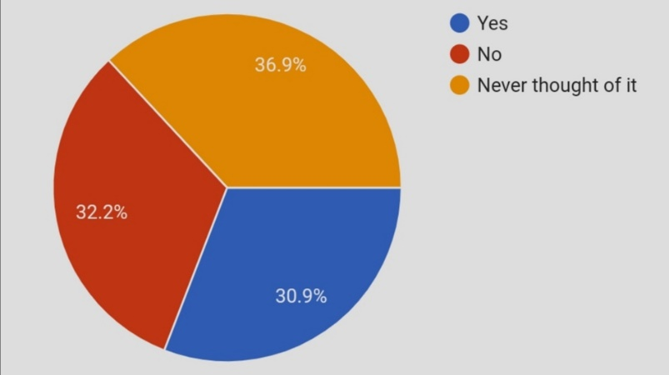 Figure 1.
Recent media reports has shown divers picking up masks and gloves that are littering the waters. Other items that are creating plastic pollution are the protective wear used by the frontliners. Items such as disposable gloves, aprons, eye protection and gowns have produced tons of single use waste during this pandemic. Even though it is not always possible to find an alternative for such medical materials since most of the time it is recommended to use them only once and dispose of, the safe handling and final disposal of this waste is a vital element that may have an effective emergency response. There are also some alternative equipment that a person can make use of to help reduce the terrible impact of this pandemic on the enviroment such as the use of fabric face masks that are washable and reusable. Another way in which one can reduce plastic pollution is by purchasing hand sanitizers that can be refilled once empty.
During lockdowns which have occured worldwide, many individuals have turned to take out meals contributing to an increased plastic demand. Take out and groceries home deliveries increased the use of plastic in plastic bags and plastic packaging.
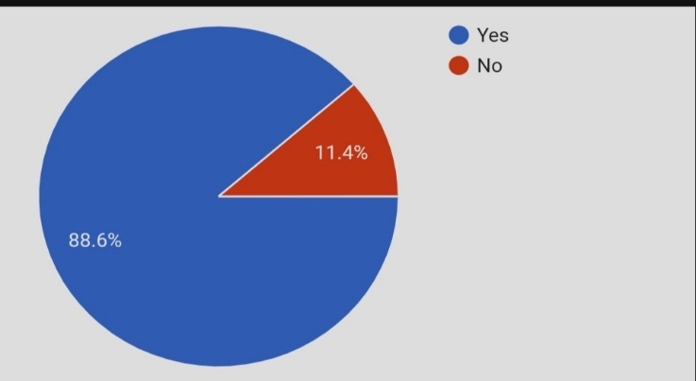
Most people are aware of the problems this pandemic has caused. However 11.4% of the people aren’t aware and this worries me. If people aren’t aware they won’t try their best to help reduce the terrible impact.
Figure 2
From the results it was clear that the large majority of respondents refill there hand sanitizer bottles and therefore they are helping reduce the amount of plastic being used. Also, the large majority consider themselves as doing your best to help the environment even during this pandemic. This question was a very important one since the only way we can improve the horrible impact is by caring and loving the enviroment around us. 64.9% shared that they do try their best to do so.
This article should shed light on the increasing threats on the environment due to the current pendemic, however each and everyone of us has the power to shift such scenario by committing to small everday lifestyle changes.

