ST ALOYSIUS PRIMARY SCHOOL
LITTERLESS CAMPAIGN – WASHED ASHORE!
Damian Azzopardi

My name is Damian Azzopardi. I am 11 years old and I am in Prep 6.
For the past two years, I have been a member of Red Warriors, a school group where we discuss how we can have a better environment. This year, the Red Warriors group is taking part in the Litterless Campaign 2020-2021. Our project is called Washed Ashore, focusing mainly on marine litter.
Our first activity was an online presentation by Ms Martina. We learnt that litter thrown in the sea and on the beaches, which is easily washed in the sea, is slowly turned into small particles, which hurt the fish and other creatures living in the waters. This in turn hurts us, as when we eat the fish from dirty waters, due to litter, can make us ill. It is a well-known fact that throwing plastic bags in the sea will harm turtles if they swallow them. Plastic bags can also harm seagulls, who fly close to the sea. If the bags get over their heads while they hit the water surface to catch fish to eat, they could choke. Oil is also very harmful, which once mixed with water, is impossible to separate. As a result, the water becomes sticky.
The Red Warriors and Water Explorers, another school group, could see this during a beach clean up in Il-Ballut ta’ Marsaxlokk , last February. We found all sort of litter on the beach : pieces of tiles, Styrofoam (gablow), small broken glass, long pieces of string, plastic cups, plastic bottle caps, plastic bottles, heavy chains, pieces of wood, a cushion and a boat battery covered in green moss which at first we thought it was a rock! We ended up collecting 228 kg of waste in just 3 hours. Some of the litter came from boats likely used for fishing and we were puzzled how most of the waste came from people who used the sea mostly as a living or as leisure.

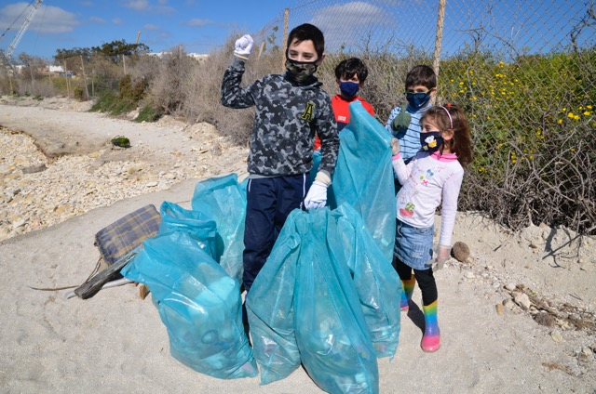

We wish that people using the sea, both as a livelihood and to enjoy themselves, take care of it more. Litter should not be left on the beaches or on the rocks, and even worse in the sea. It should be disposed of properly : heavy items in bring in sites and small items in garbage cans on the beach or otherwise taken home and thrown away in bins.

We designed a slogan to communicate our message. This was my message:
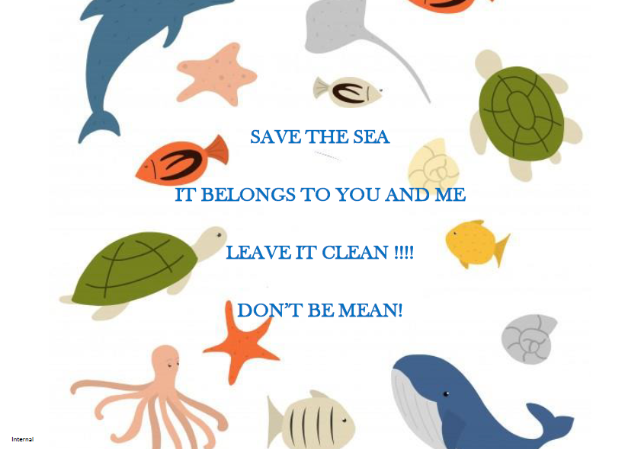

The sea is for everybody to enjoy so we should do our best to protect it. Not doing so, is showing cruelty towards the sea creatures and we would be disrespectful to other people. We will get our message across by printing the slogan on cloth bags which are then distributed to all the students at our school.
Being part of this project, I learnt that although plastic is a helpful material, it can do more damage than I thought. The people who litter do not care and they are not aware of what is happening to our sea where we swim and get food from.
Some of the litter can also be recycled and not thrown away!

