Maltese Islands Biodiversity

Faces Extinction!
By Nicholas Micallef – Year 6 Zaghfran

The Maltese Islands’ biodiversity is under threat, and something must be done in the coming years. Although the islands are home to a lot of different animals, insects and plants, they are all facing multiple threats. These species include the Maltese Horned Pondweed, the Tadpole Shrimp and the endemic orchid species, Maltese Pyramidal Orchid.
The biodiversity of the islands is under threat from many factors, for example, natural processes of bio diversification, other species which are not naturally found on the islands (invasive), natural disasters, and human-made problems. Unfortunately, the public is uninformed about biodiversity and protected species across the Islands, as well as being unaware of the permissions needed to cut or uproot certain trees or plants. This is obvious when considering that about 60% of the Maltese population does not know what the Natura 2000 directive states.
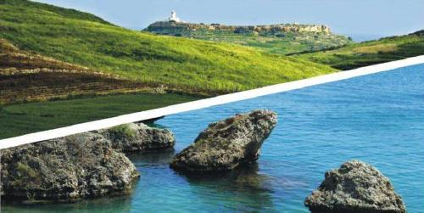
To give the Maltese biodiversity a chance there are many items which can be actioned by different parties. Starting with, biodiversity needs to be included in government policies, general law, and sustainability agreements. Ideally, we would also implement the management measures outlined in the Natura 2000 documents on all sites which require preservation. Education can also bring with it results, allowing the public to understand better the effects of our actions on the surrounding environment. Ideally, we could also try to remove the invasive species which destroy natural species, apart from creating better monitoring for all sites to try and stop illegalities which happen daily. Hunting and trapping should also be watched to make sure that the limits set by the law are kept and that no protected species are caught illegally.
Without focusing on any of the above, the Maltese Islands might face damage which cannot be reversed and will have failed to target SDG 15: “Protect, restore and promote sustainable use of terrestrial ecosystems, sustainably manage forests, combat desertification, and halt and reverse land degradation and halt biodiversity loss”.

