Including Disability in a growing, environmental society
For a long time, people with disabilities have been underrepresented. So, now I have decided to give them a voice by asking them for their personal opinion on Malta’s schools.
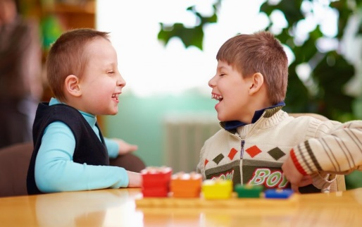
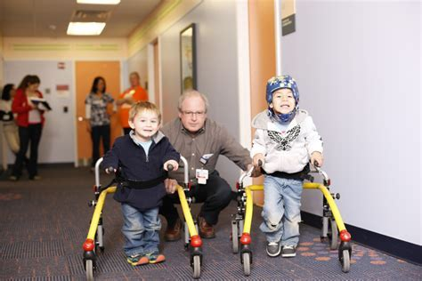
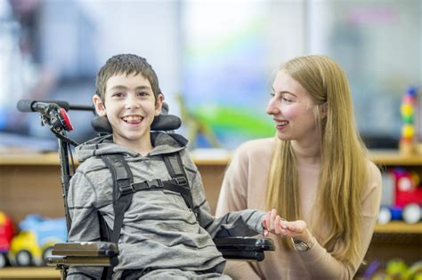
(all pictures taken from www.disabilityeyeopener.com )
Before writing this article, I asked many of my friends with different abilities about their experience in Malta’s state schools. Both primary and secondary. Many of them said that their academic experience has generally been very positive. For example, the teachers all do their utmost to make sure that all students feel included regardless of whether the disability is mental or physical and that their special arrangements (special requirements for exams and throughout the year) are acknowledged, that they are treated equally as the other students and not excluded. Nonetheless, there is one lesson where almost all of them say that they are left out. Specifically, the PE lessons.
“I am not included in all activities. For example, the P.E lesson.” - John
They say that they are not included and just left to watch, (just to clarify, this is not the case for everyone. Some have found ways to substitute the lesson or be included in their own way. For example, doing their own stretches on the side). Some also say that many other students decide to stay with them during the lessons so they don’t feel excluded.
Often times, certain outings are also altered for the good of the student. For example, it is made sure that (if the outing involves a lot of movement) different, shorter routes are found so the student can still take part. Also, if the student has a particular walking or transportation aid, the route may be changed to somewhere more smooth. If they have to do an activity that is not comfortable or tires them out too fast, the activity can be altered or (in some cases) completely changed.

Reverting back to PE, not only the students have developed an opinion on the matter, but also the teachers. One says that new ways of reducing restrictions are needed so that every student can have the freedom of taking part in a lesson in a way they see fit.

“We need to consider ways of minimising or reducing these barriers so that everyone can fully take part and learn.”-HOD for PE.

Many of the teachers who I’ve asked also say that by further altering the PE lessons and finding ways to include everyone, many more students can start to not only fully enjoy the lessons and find a love for physical activity, but also find ways to incorporate this vital subject into their daily lives.

This can be done, according to PE teacher, Lorna Mifsud, by dedicating more lessons to sports that focus on particular aids. This includes Wheelchair Basketball, Wheelchair Volleyball, or even Frame Football. Not only will this make disabled students feel more included, but it will also give able-bodied students a chance to experience the different ways different people can play different sports.
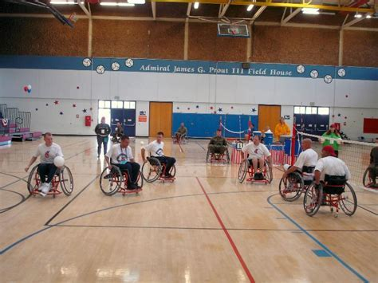
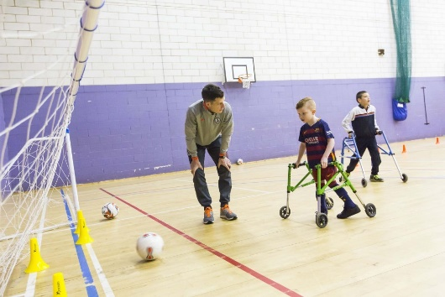
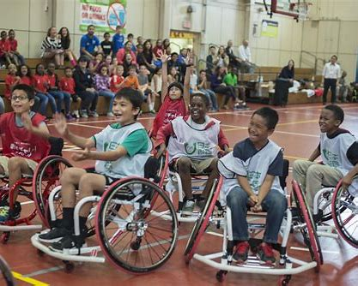

“I want to include everyone because the P.E lesson is for everyone” P.E Teacher Lorna Mifsud

Maja Ruzicic 9.7
St Benedict College, Kirkop Secondary School

