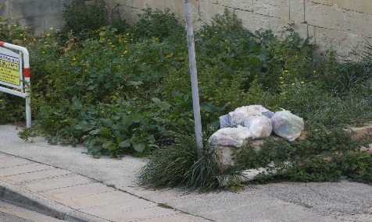
No to rubbish on streets
All over Malta, we can see a situation where people are throwing rubbish on the streets for others to collect. This causes many problems. Street cats tear the bags and all that was inside them ends up on the floor polluting Malta. Because of this streets become dirty and sometimes due to wind, everything that was inside the rubbish baends up all overthe street. Sometimes rubbish sits on the street for more than one day. This causes an awful smell which gets even worse in summer. To hear others' opinions on this we went to the streets of Malta.

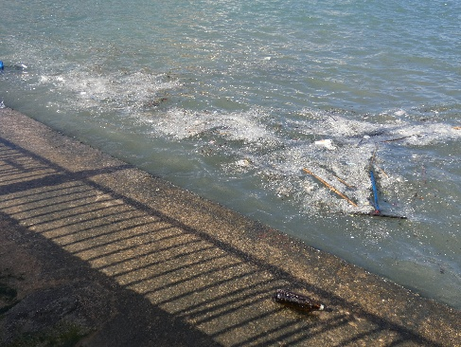
“ I disagree with the idea of polluting our country and our Planet, throwing rubbish outside just on the streets causes a large amount of rubbish in the sea We should find another way to dispose of rubbish ”
“I believe it is disgusting. We live in a first-world country and I still see litter in our streets. The people in power are not giving importance to this grave issue for many taxpaying Maltese like me.”
“I took my dog, Rusty, by Mellieha for a walk a few weeks ago, I unleashed him to play at the beach. He saw a fish zooming by he caught a bottle instead, we had to rush to the closest clinic for it to be removed.”
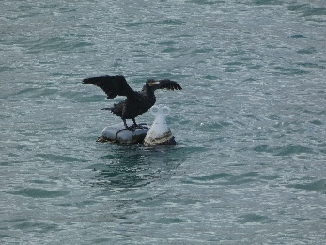
The last story shows us how rubbish on the streets affects animals. Sea animals are in huge danger too. Lots of rubbish gets into the sea. And thenfish, birds, and other sea animals need to live in poisoned water. The rubbish has no exact place where to be stored , so it is just everywhere. Different animals can eat microplastic and become sick.
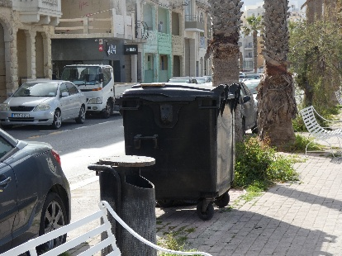And this all can be avoided just by adding some big rubbish bins on the streets. It is possible to even today to see them in Malta, but they are all full and closed or you can see them very rarely. If every street had the working three different types of bins (recyclable, non-recyclable, and organic), the sea and streets would be much cleaner and animals would be healthier

