Metal thrown in a field
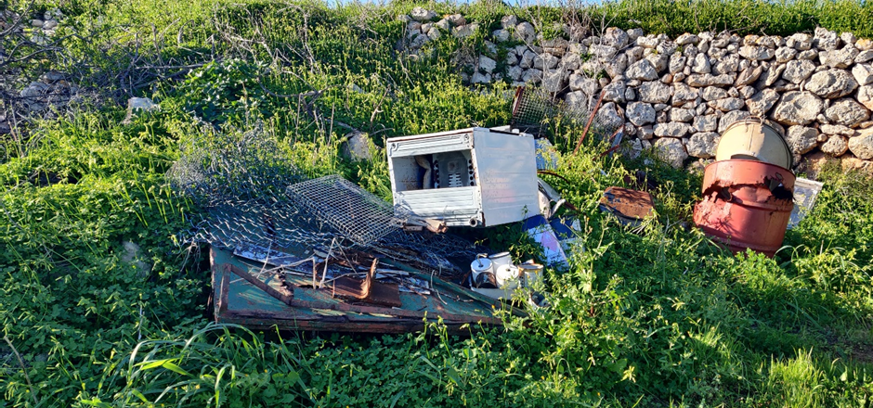
On Thursday 15th February 2024 at 12 o'clock, a bunch of metal thrown in an abandoned field was seen. This was harmful to the grass and the trees around it.

A lot of the metal was old and rusty which made it harmful and dangerous to humanity and nature. A lot of the metal could have been reused while the rest could have been thrown away at the WasteServ’s Civic Amenity sites. Sadly, a rabbit was harmed because its neck got stuck under a barrel, but he was taken to the vet quickly to get cured.

All the metal that was found was taken to the WasteServ’s Civic Amenity sites. There was a lot of rust on the grass so that means that the metal was there for decades making it hard to clean the grass. Why, you ask, do I need to clean the grass? I need to clean the grass because if any animal that likes grass, for example the sheep, eats it, this might lead to stomach problems and even death.

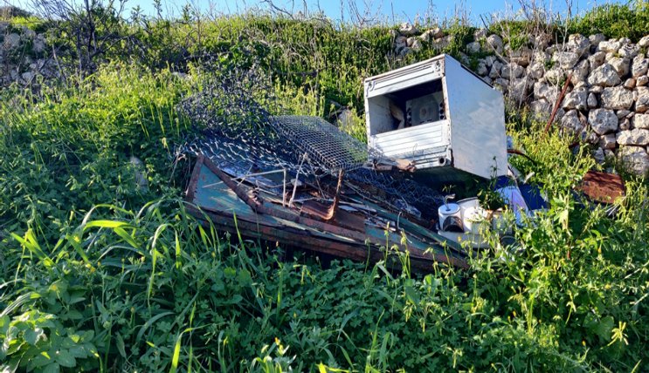
Surprisingly it took about a week to clean it off the grass, spraying 5 litres a day of glyphosate but finally it was clean for animals to eat …but not for all animals. Some animals have a strong stomach which can digest things that are harmful only to us for example crocodiles, sharks and vultures.

In conclusion this problem was fixed and taken care of so the environment or at least a part of the environment could be happy and unharmed.

Denzyl Micallef

